**Assignment-2**

|  |  |
| --- | --- |
| **TEAM ID** | PNT2022TMID49581 |
| **PROJECT NAME** | CUSTOMER CARE REGISTRY |
| **NAME** | ANANTHA KRISHNAN P |
| **ROLL NO** | 950019104001 |

**1.Create registration page in html with username, email and phone number and by using POST method display it in next html page.**

**Program:**

register.html

<!DOCTYPE html>

<html>

<head>

<meta charset="UTF-8">

<meta http-equiv="X-UA-Compatible" content="IE=edge">

<meta name="viewport" content="width=device-width, initial-scale=1.0">

<title>Registration form</title>

</head>

<body>

<center>

<form action="{{ url_for("register")}}" method="post">

Name : <input type="text" name="user"><br><br>

Email id : <input type="text" name="email"><br><br>

Phone Number : <input type="text" name="phone"><br><br>

<input type="submit" value="Submit"><br>

</form>

</center>

</body>

</html>

app.py:

from flask import Flask, request, render_template

app = Flask(__name__)

@app.route('/', methods =["GET", "POST"])

def register():

if request.method == "POST":

name = request.form.get("user")

email = request.form.get("email")

phone = request.form.get("phone")

return "Name is : " + name + ", Email is : " + email + ", Mobile Number is : "+ phone

return render_template("register.html")

if __name__=='__main__':

app.debug=True

app.run()

**Output:** 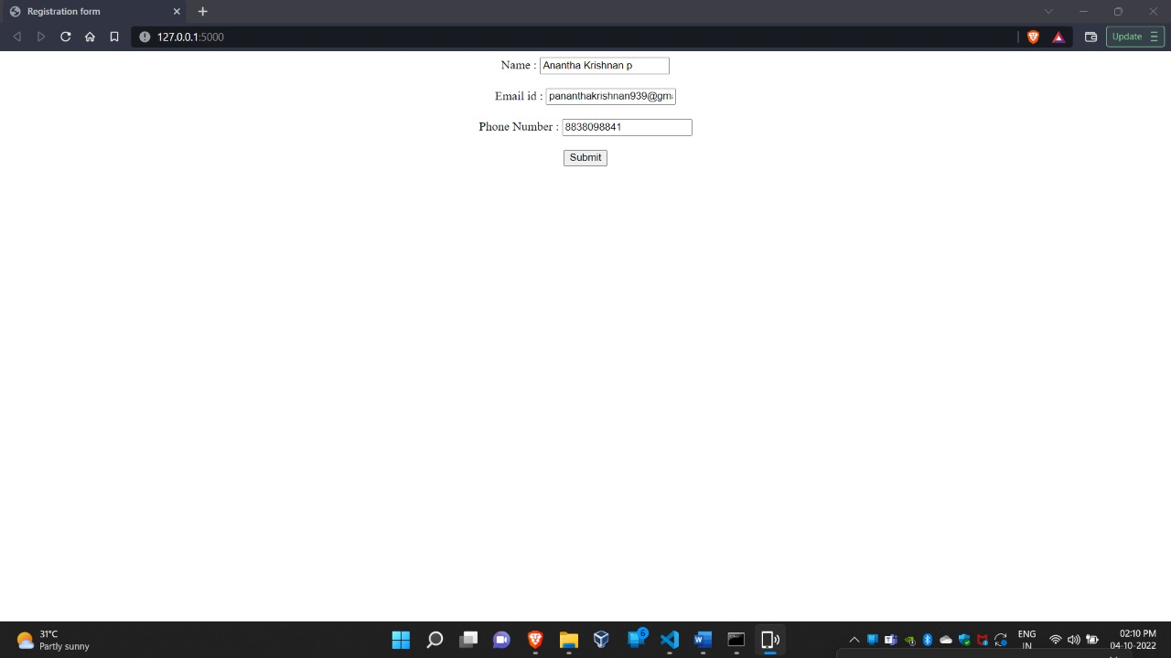

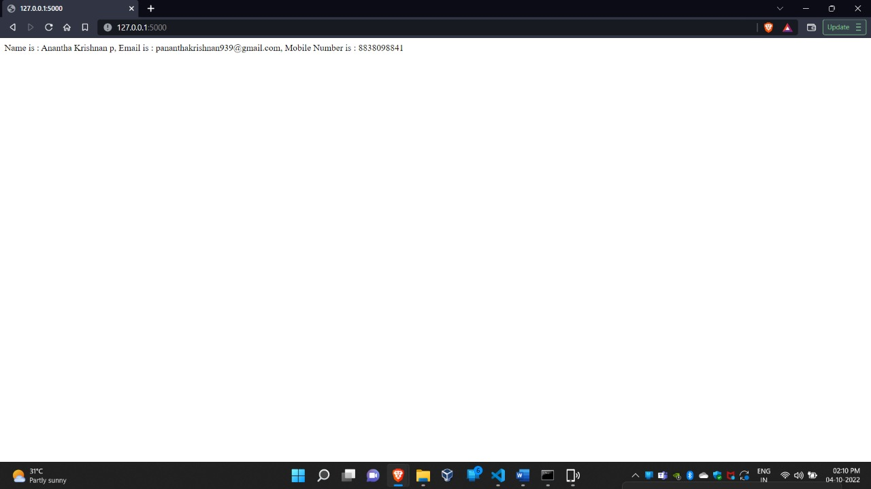

**2.Develop a flask program which should contain atleast 5 packages used from pypi.org**

base.html:

<!DOCTYPE html>

<html>

<head>

<title>Page Title</title>

{% block head %} {% endblock %}

<link href="https://cdn.jsdelivr.net/npm/bootstrap@5.2.1/dist/css/bootstrap.min.css" rel="stylesheet" integrity="sha384-iYQeCzEYFbKjA/T2uDLTpkwGzCiq6soy8tYaI1GyVh/UjpbCx/TYkiZhlZB6+fzT" crossorigin="anonymous">

<script src="https://cdn.jsdelivr.net/npm/bootstrap@5.2.1/dist/js/bootstrap.bundle.min.js" integrity="sha384-u1OknCvxWvY5kfmNBILK2hRnQC3Pr17a+RTT6rIHI7NnikvbZlHgTPOOmMi466C8" crossorigin="anonymous">

</script>

</head>

<body>

<a href="/">HOME</a>

<a href="/Blog">BLOG</a>

<a href="/Signin">SIGN IN</a>

<a href="/Signup">SIGN UP</a>

<hr><br>

<div class="container">

{% block body %} {% endblock %}

</div>

</body>

</html>

blog.html:

{% extends 'base.html' %}

{% block head %}

<title>Blog Page</title>

{% endblock %}

{% block body %}

<h1>This is My Blog</h1>

<h2><p>Hello, from Home Page</p></h2>

{% endblock %}

index.html:

{% extends 'base.html' %}

{% block head %}

<title>Home Page</title>

{% endblock %}

{% block body %}

<h1>Hello everyone,</h1>

<div class="p-5 mb-4 bg-light rounded-3">

<div class="container-fluid py-5">

<h1 class="dispay-5 fw-bold">CLOTHING WORLD !</h1>

<p class="col-md-8 fs-4">Clothing (also known as clothes, apparel,

and attire) are items worn on the body. Typically, clothing is made of fabrics or textiles, but over time it has included garments made from animal skin and other thin sheets of materials and natural products found in the environment, put together. The wearing of clothing is mostly restricted to human beings and is a feature of all human societies</p>

</div>

</div>

{% endblock %}

signup.html:

{% extends 'base.html' %}

{% block head %}

<title>Signup Page</title>

{% endblock %}

{% block body %}

<h1>Signup Page</h1>

<form action="Signup" method="POST">

<label>Name</label><br>

<input type="text" name="name"><br><br>

<label>Email</label><br>

<input type="email" name="email"><br><br>

<label>Phone</label><br>

<input type="text" name="phone"><br><br>

<label>Password</label><br>

<input type="password" name="name"><br><br>

<label>Retype Password</label><br>

<input type="password" name="name"><br><br><br>

<input type="submit" class="btn btn-primary">

</form>

{% endblock %}

signin.html:

{% extends 'base.html' %}

{% block head %}

<title>Signin Page</title>

{% endblock %}

{% block body %}

<h1>Signin Page</h1>

<form action="/Signin" method="POST">

<label>Email</label><br>

<input type="email" name="email"><br><br>

<label>password</label><br>

<input type="password" name="name"><br><br>

<input type="submit" class="btn btn-primary">

</form>

{% endblock %}

app.py:

from flask import Flask, render_template

app = Flask(__name__ )

@app.route('/', methods =["GET", "POST"])

def Index():

return render_template('index.html')

@app.route('/Blog')

def Blog():

return render_template('blog.html')

@app.route('/Signup')

def Signup():

return render_template('signup.html')

@app.route('/Signin')

def Signin():

return render_template('signin.html')

if __name__ =='__main__':

app.debug = True

app.run()

**Output:**

